MARMARA UNIVERSITY
FACULTY OF ENGINEERING
COMPUTER ENGINEERING

PHYS1103
PHYSICS LABORATORY
EXPERIMENT 4
Projectile Motion
SXGXE4

NAME | STUDENT NUMBER

Submitted to: Hüseyin YALTIRIK

Experiment Date: 05.11.2019 Due Date: 19.11.2019

1-) PURPOSE
The aim of this experiment is leaving an object horizontally with an initial velocity and examine movement of the object separately on vertical and horizontal axes.
2-) THEORY
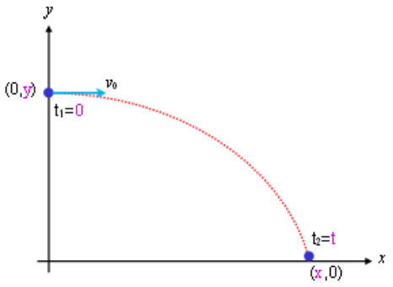
As we saw in the figure in this situation there is only two planes, we call the horizontal plane x-axis and for the vertical plane y-axis. In the figure there is an object which thrown horizontally. In the earth’s circumstances if we throw an object horizontally there will be only gravitational force which only effects the object on the vertical plane. Name of that is projectile motion. In the figure we saw the dots which are shows us the position of the object in another times. We symbolize the time with t. There is a horizontal and a vertical velocity vector. The horizontal vector is parallel to x-axis and the vertical vector is parallel to y-axis. The presentation of velocity is:
$$\vec{v}=v_{x} \hat{i}+ v_{y} \hat{j}$$

In this experiment horizontal velocity is constant, only the gravitational acceleration effects the object in vertical plane. Because of that object only have a constant vertical acceleration
and it does not have horizontal acceleration. Vertical velocity will change with time in the same amount. Separately the accelerations are:

$$a_{x}=0$$
$$a_{y}=a$$

There is no acceleration on x-axis velocity will be same in any time. There is gravitational acceleration on y-axis velocity will increase with same value time after time.

The acceleration shown in vector form like:
$$\vec{a}=a_{y}\hat{j}$$
The position in a time is:
$$\vec{r}=x\hat{i}+y\hat{j}$$
The kinematic equations for constant acceleration in two-dimensional motion:

x-Component | y-Component
$$v_{x}=v_{0x}+a_{x}t$$ | $$v_{y}=v_{0y}+a_{y}t$$
$$x= x_{0}+v_{0}t+\frac{1}{2}a_{x}t^{2}$$ | $$y= y_{0}+y_{0}t+\frac{1}{2}a_{y}t^{2}$$
For examine two-dimensional projectile motion, an object will stand on an air table. When we give the air to system the object will move on the frictionless plane.

Let’s suppose at time t=0 the object at ($x_{0}, y_{0})$ point and its initial velocity components are $v_{0x} and v_{0y}$. The horizontal velocity is constant so:
$$a_{x}=0$$

$$v_{x}= v_{0x}$$

$$x= x_{0}+v_{x}t$$

We can choose the axes of our coordinate system at the start point of object at t=0 and take the downward direction to be positive like:

$$x_{0}=y_{0}=0$$

That’s the origin of our experiment. From $x= x_{0}+v_{x}t$ equation the motion on the x-axis is:

$$x= v_{x}t$$
If we know the horizontal displacement and time to flight, we can find the initial velocity of the object

For y-axis the velocity and vertical displacement:

$$v_{y}=at$$

$$y= \frac{1}{2}at^{2}$$

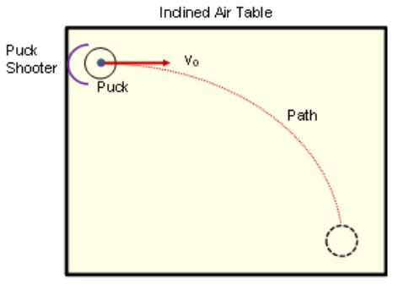
Schematic diagram of object on inclined air table and dots produced by object. The x-component of the velocity is constant but as we saw in the scheme velocity for y-axis increases by time.
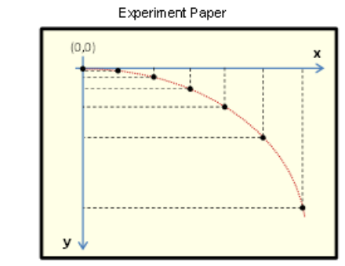
In projectile motion there is a constant horizontal velocity and constant vertical acceleration. The vertical distance change between dots shows there is an acceleration and velocity increase downward. The horizontal distance change between dots are always same, that shows the horizontal velocity is constant.

In projectile motion the x-axis and the y-axis are does not any effect to each other. We can think like they are two different motion and we can do calculations without thinking the other motion in the other plane.

So, the horizontal velocity is constant and horizontal acceleration is zero, the vertical velocity increases by time and vertical acceleration is constant.

3-) EXPERIMENTAL SETUP
The materials that have been used in this experiment are:

• Hover puck system
• Ruler
• Pen and paper
• Calculator

Firstly, the voltage of experiment system has been adjusted. After that, experiment has started with measurement of road taken separately on vertical and horizontal axes. Spark timer frequency has been set to f=20Hz.
4-) CALCULATIONS & RESULTS
This is equation for calculating position of the object.
$$x\left(t\right)=x_{0}+v_{0}t+\frac{1}{2}at^{2}$$
Table 1 Horizontal velocity of the projectile motion
Frequency  f (Hz) | Dot  Number | Trajectory-B (x -Horizontal Component Motion)
Frequency  f (Hz) | Dot  Number | x(m) | t(sec) | X(m) | t(sec) | v(m/s)
Frequency  f (Hz) | Dot  Number | (Measured) | (Measured) | (Calculated) | (Calculated) | (Calculated)
20 | 0 | 0 | 0 | 0.249 | 0.500 | 0.498
20 | 1 | 0.023 | 0.05 | 0.249 | 0.500 | 0.498
20 | 2 | 0.049 | 0.10 | 0.249 | 0.500 | 0.498
20 | 3 | 0.071 | 0.15 | 0.249 | 0.500 | 0.498
20 | 4 | 0.093 | 0.20 | 0.249 | 0.500 | 0.498
20 | 5 | 0.121 | 0.25 | 0.249 | 0.500 | 0.498
20 | 6 | 0.145 | 0.30 | 0.249 | 0.500 | 0.498
20 | 7 | 0.169 | 0.35 | 0.249 | 0.500 | 0.498
20 | 8 | 0.197 | 0.40 | 0.249 | 0.500 | 0.498
20 | 9 | 0.224 | 0.45 | 0.249 | 0.500 | 0.498
20 | 10 | 0.259 | 0.50 | 0.249 | 0.500 | 0.498

Table 2 The measurements of accelerations for the trajectory-A and trajectory-B
Dot  Number | Trajectory-A |  | Trajectory-B |  | Trajectory-A | Trajectory-B
Dot  Number | (Vertical Motion) |  | (Vertical Motion) |  | (By the slope) | (By the slope)
Dot  Number | y(m) | t(sec) | y(m) | t(sec) | a (m/s²) | a (m/s²)
0 | 0 | 0 | 0 | 0 | 2.912 | 2.144
1 | 0.015 | 0.05 | 0.004 | 0.05 | 2.912 | 2.144
2 | 0.029 | 0.10 | 0.012 | 0.10 | 2.912 | 2.144
3 | 0.048 | 0.15 | 0.023 | 0.15 | 2.912 | 2.144
4 | 0.070 | 0.20 | 0.040 | 0.20 | 2.912 | 2.144
5 | 0.103 | 0.25 | 0.061 | 0.25 | 2.912 | 2.144
6 | 0.141 | 0.30 | 0.095 | 0.30 | 2.912 | 2.144
7 | 0.189 | 0.35 | 0.122 | 0.35 | 2.912 | 2.144
8 | 0.240 | 0.40 | 0.169 | 0.40 | 2.912 | 2.144
9 | 0.299 | 0.45 | 0.215 | 0.45 | 2.912 | 2.144
10 | 0.364 | 0.50 | 0.268 | 0.50 | 2.912 | 2.144

Graph 1 Position as a function of the square of time for the trajectory-A

Graph 2 Position as a function of the square of time for the trajectory-B

5-) CONCLUSION & DISCUSSION
- Only acceleration on the y-axis is gravitational acceleration, because of that acceleration on the y-axis is constant.
- In our measurements there is always an uncertainty. If we take a look to our experiment data values for horizontal plane, we saw the position change in any time interval is approximately same.
- Because of there is no force in horizontal plane there won’t be an acceleration, so the magnitude of acceleration equal to zero. Since there is no acceleration there won’t be a velocity in horizontal plane. The velocity always will be equal to zero.
- Since there is gravitational acceleration to downwards the object will get faster with time, the velocity of the object will increase in each time interval.
- Only force to downwards is gravity force, so only effect to acceleration will be that and because of it does not change acceleration of the object will be constant all the time.
6-) REFERENCES
- Rentech Laboratory Manual and Workbook, Ankara, 2015

7-) APPENDIX
